**Create users:**

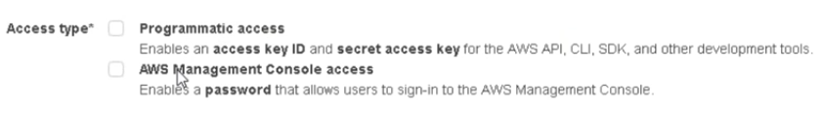

* On creating user, there are two types of access. AWS management console access gives console access to user. He can login and have own console
* Programmatic means, AWS can be accessed with CLI as well. On Linux machine, we can install AWS CLI and launch the instances or start or stop etc. from CLI with access keyID and secret file, we can’t create password for programmatic user
* If we want to automate the AWS like create ec2 instance, we may use Jenkins, python, ansible. To access the AWS with tools, we need programmatic access

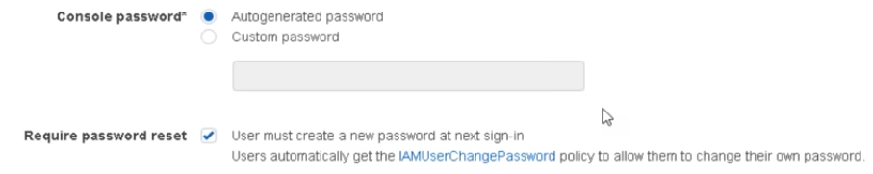

* There are two types of console passwords and we can restrict user to change the password on next login
* In the next step, we can give permissions, or we can add user to existing group or create another group and assign policies to that as below
* Policy means set of permissions we give to the users
* If we select the option **“user must change the password in next login”** as above, then there is a policy **“IAMUserChangePassword”** will be added to the user and enables user to change his own password

**Groups:**

* Under groups, we can create groups, assign policies and add users to the groups instead of adding multiple policies to each user
* So, create a group, add policies to that and add users to the group
* After creating group, an ARN will be created for resource. Amazon Resource Number is unique number gets created for every resource
* There are some account settings for password policy etc.

**Assign Policies:**

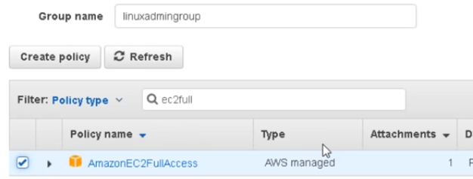

* Once we create the user, it will generate a new link for user to sign in and a password will be available in .CSV file
* We need to download it and send the user

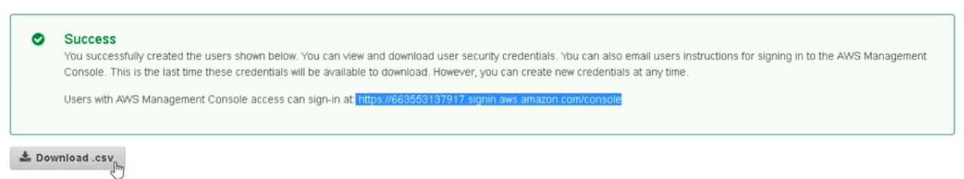

* After user creation, user cannot access the account directly, there will be link displayed with which user needs to access
* Under users🡪 security credentials, we can find the URL here later also
* With JSON syntax, we can create a policy. We can copy the old policy and make changes to create new one

**Recommendation:**

* It is recommended to deleted access key id and secret key if of root account as below
* It is better to stop using root account. Better to create admin account and use it

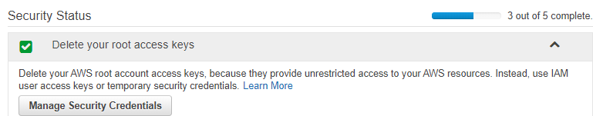

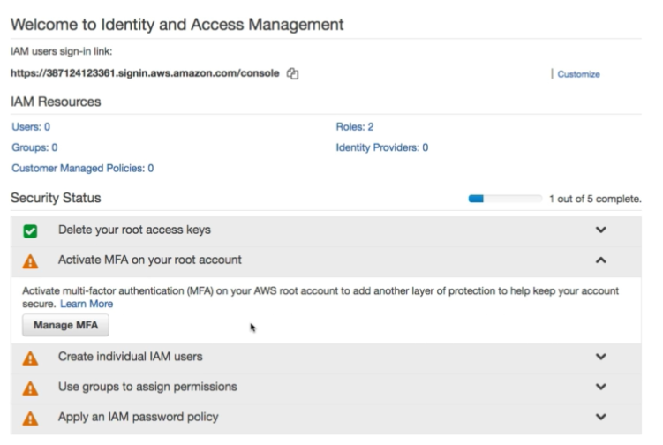

Above are the security recommendations from amazon.